Design Report

Saim SUNEL 240201068

11/05/17

UI Desing

Web Application

WebApplication Map

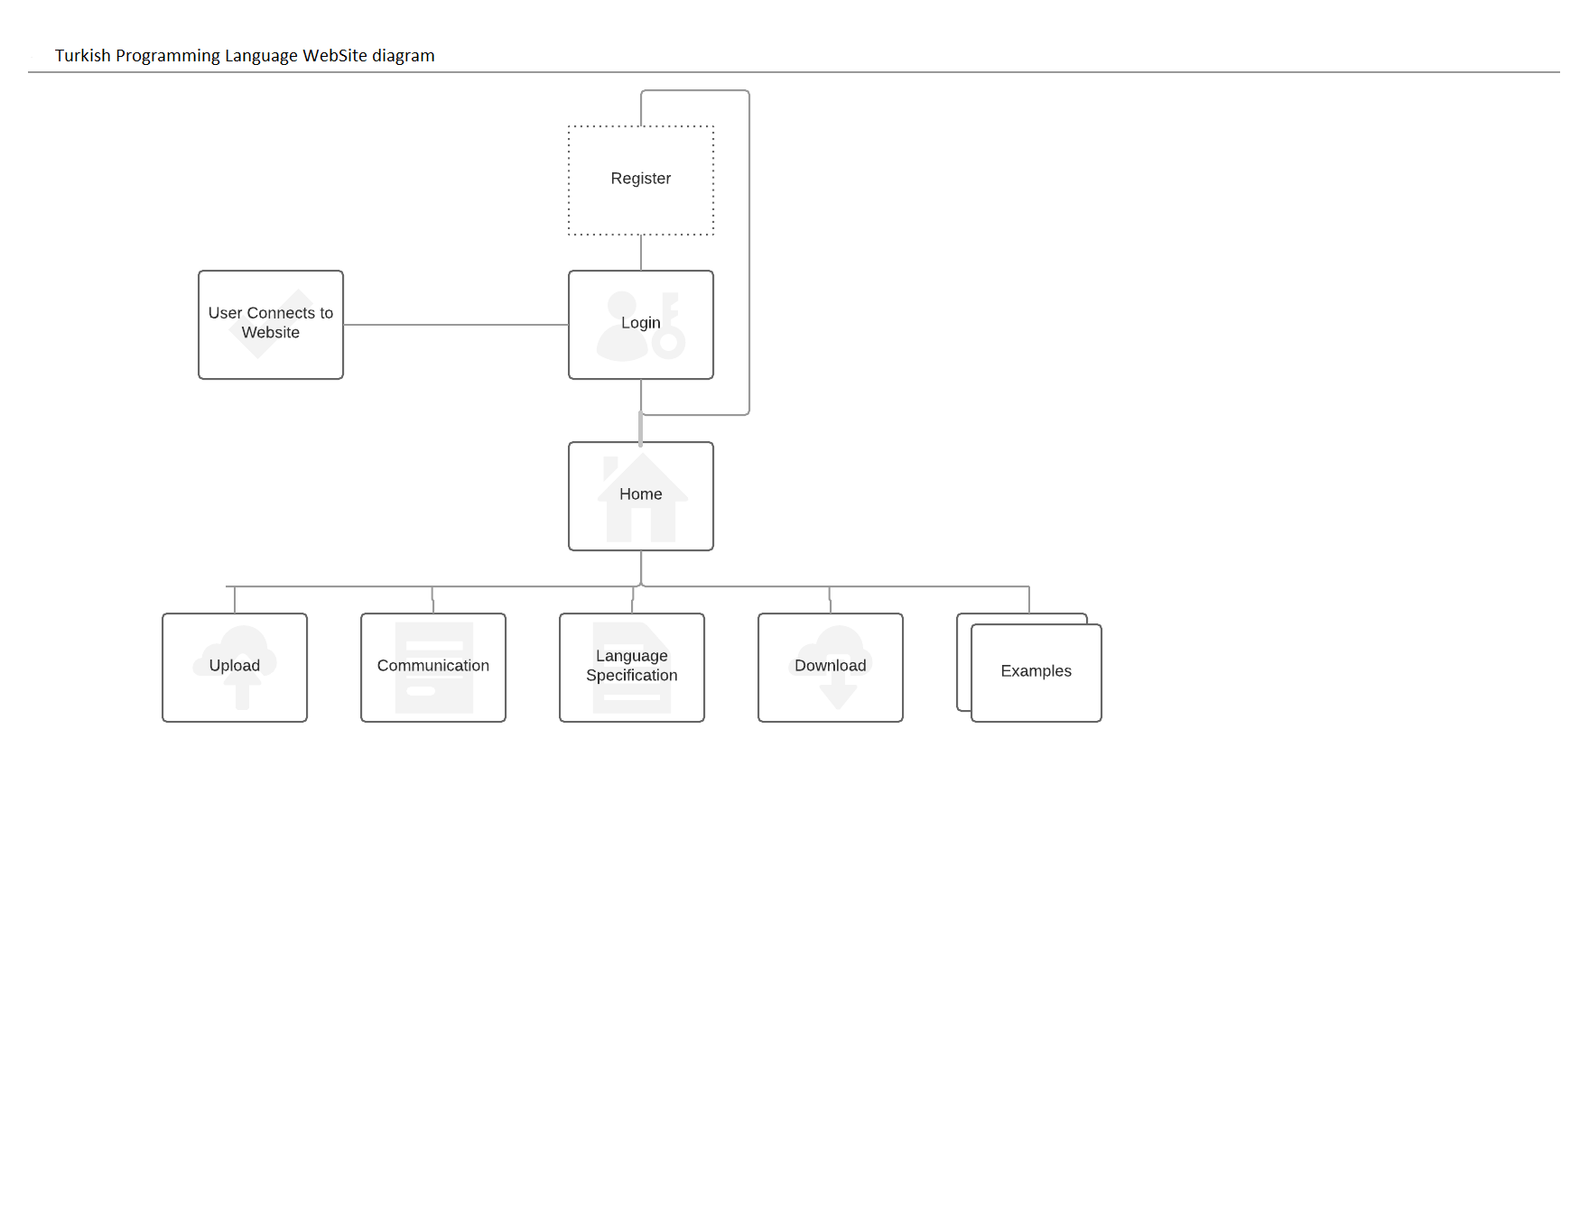

In website application, when the user connects to the website first login page will be shown.If the user is not registered yet , he/she can pass to the register website.After registration the user again will come to the login page.After login page the home page will be shown.In the home page the user can access to the entire website.The upload and download webpages do not have a GUI.They are the pages that perfroms the file upload and the download tasks.And from the every page except login and register page the user can return to homepage for accesing other pages.

Registration Page

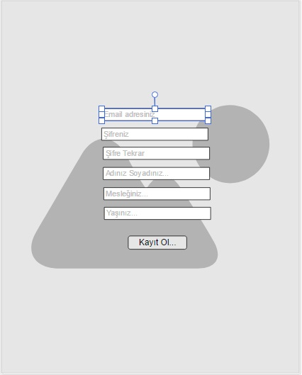

Description Tasks

This page is created for the user registration.When a new users wants to join the web servise he/she has to perform login operation.The webpage has a background covering the whole page.It has 6 textbox that will be used in obtaining the user information.And there is registration button. In email address section the user must enter the his/her email address properly, if an invalid written email adress is detected the web page display the error. Then the user must enter his/her password that will be used in the login operation.

There is no limitation on the password number.The password of the user is wanted two times due to typo errors.We must sure that the user entered the password without type errors.Then the user must enter the name and surname of him/her.Then the occupation that he/she posses , then the age of him/her.All the information required from the user must be filled.If there is a missing part then the program will show the error message.After filling the all the section when the user presses the Kayıt Ol... button the website will add this new member to the database of it.And login page will be requested.

Login Page

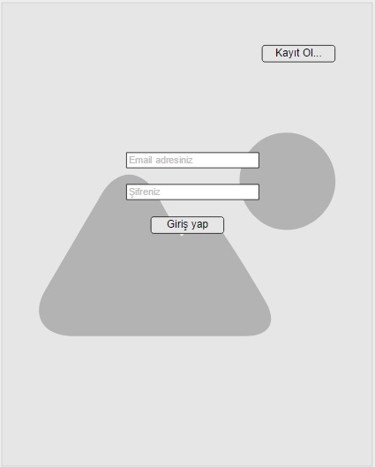

Description and Tasks

This is the login page of the web application of our system. When the user types the URL of the website , this page will be shown. The webpage has a background image that covers the whole website.Two button for page chaging and two textbox for taking the information of the user.

The user must enter his e-mail address and the password of him/her which is registered before.If the user is not registered , he/she can pass to register page by clicking the Kayıt Ol... button at the right top of the page. If the user types a wrong e-mail or the password the error message will be shown properly.The e-mail address structure is checked and if the structure is okay then the email address and the password is compared with database if the user exists then the user is transfered to the main page. If the password or the password does not match then the error message will be popped up when the Giriş Yap... button is pressed.

There will be a error message panel.When that is popped the remaining webpage will be disable to access of the user.Then the user may try again or go to the registration page.

Main Page

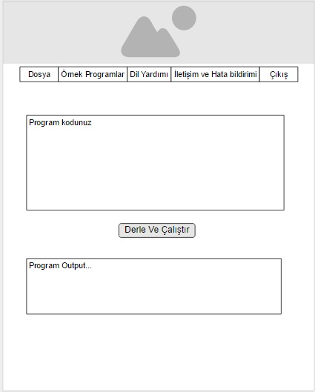

Description and Tasks

This is the main page of the website.The user will perform all the operations of him/her from this webpage.The webpage contains an image at the top of the page. It contains a pulldown menu bar which connects the main page to the other webpages. On textbox for program code that the user will code. And a button for running the written code. And finally a box that will be containing the ouput of the program.

If the log in operation is in success, the user will be transferred to this page.The user will perform all the operations on this page.In the menu section :

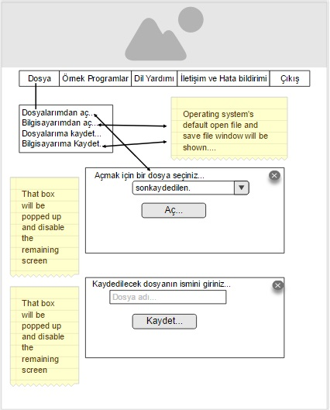

When the user presses the Dosya submenu a pulldown menu will be displayed.In this pulldown menu the user can perform saving the code to the database of him/her or to this Pc , or read a file from his database or from his/her PC to the page.When a file is read either from the PC or database the read code will be put in the code section of the webpage.And the save operation will take the code in the code section of the page and save it to database or the PC as a file.

When the user presses the Dosyalarından Aç... the show popup menu will be shown. And the remaining webpage section will disabled to the access of the user.And the user may cancel the opening operation from the database by clicking the cross symbol at the right top of the panel.Then panel will contain all the file’s of the current user in the database.The user chooses a file then presses the Aç... button , the file that is specified will be read from the database and the code of it will be put into the code section of the page.

When the user presses the Bilgisayarımdan aç... menu item , the Open file window will be displayed and the user will choose a file from his/her own PC and when the choosed the file the webpage will read the file from the PC of the user and put the code to the code section...

When the user presses Dosyalarıma kaydet... A save popup panel will be displayed shown at above.And the remaining webpage section will disabled to the access of the user.The user may cancel the saving operation by clicking the cross symbol at the right top of the panel.Then the user enters the new file name , if an exisiting file name in the database is entered the user will be warned by a popup message.If the user enters a nonexisting name in the database then the code will be saved to database.

When the user presses the Bilgisayarıma kaydet... a Save File window will be displayed then the user enters the new file name and presses Save.Then the website will take the code in the code section and put it into a file and send it to PC of the user.

The Örnek Programlar section will direct the user to the examples page of the website when the user clicks to it.

The Dil Yardımı section will transfer the user to the language specification page of the website when the user clicks to it...

The user may want to communicate with the website authors or inform the author about a bug in the website or the in the language interpreter. When the user clicks this button , the user is transferred to the communication page of the website.

And final Çıkış button will perform the log out operation when the user clicks to it. And the login page will be displayed.

The user writes his/her code to the code section of the page.

When the user pressed the Derle ve Çalıştır button , the website will send the code in the code section to the interpreter and run the interpreter , when the interpreter finishes running the code the output of the program or the error message will be shown in the output section of the webpage.

Examples Page

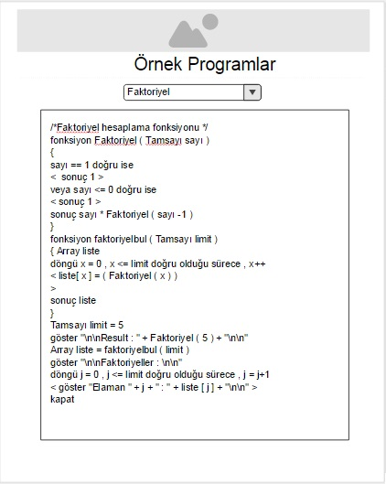

Description And Tasks

If the user wants to see the code example of the language he/she comes to this page.This page contains an image at the top. A headline text indicating the webpage and a combobox that lists the code examples.And finally a textbox in which the code example is put.

When the first enters the page , one of the example will be shown as default.

The user will choose the example from the combobox menu.Whenever the user changes the example combox selection, automatically the corresponding code example is shown the text area.The examples will be put as file in the server and when requested the next example code will read from the file and put in into the code part of the page.

Language Specification

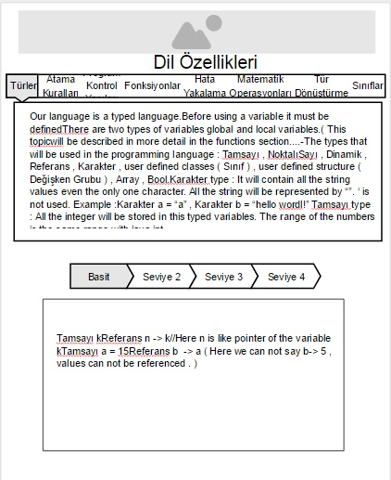

Description and Tasks

This is the page where the all language documentation is provided.The page contains an image at the top.A multi selection bar , a difficulty level bar and a file textbox that will display the code.

First the user will a topic about which he/she wants to learn.When the user clicks any section of the selection bar , the releated information will be shown at the textare underneath of the bar.

Then the user may want to see different diffuculty leveled small code example releated to that topic which is choosen before.When the user changes the code difficulty level by clicking the level labels , the corresponding small code will be automatically displayed in the code part.

When the user enters the webpage one topic will have been choosen as a default information.

Whenever the user changes the topic the simple code level of the topic will be shown as default...

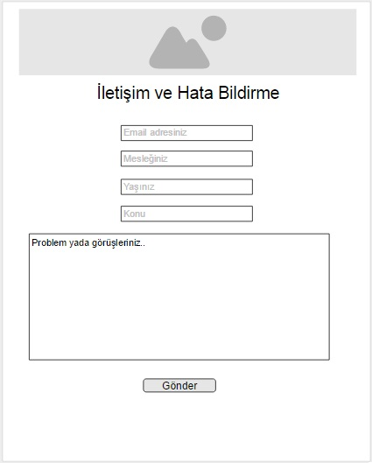Communication Page

Description and Tasks

This is the page where the user will send message to the author of the website.

The page containg an image at the top.An headline indicating the page.For small text boxes for taking the user information and a final big box for writing the message.

If the user wants to contact with author of the language , or inform about a bug in the system he/she may use this page.

The user must enter a valid structured email address. Then he/she must enter his/her occupation , age and the topic of the message and finally the message itself. When the user presses the Gönder button the e-mail address structure will be checked , if there is section not filled by the user the user will be warned to fill the missing section.If every information is filled than the webpage will send an e-mail to the author of the page.

Desktop Application

Main GUI

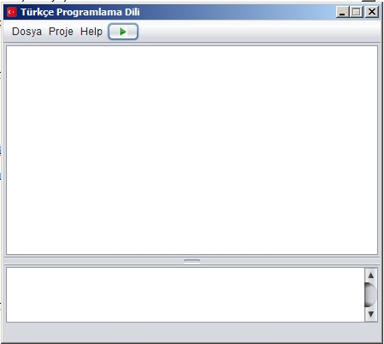

Description and Task

This is the main program of the desktop application.All the operations are performed from this windows.In contains a menu bar with three menus and a button.

Window size is fixed user can not change the size of the window...

When the user clicks to Dosya menu.

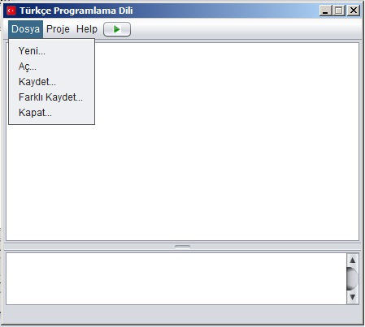

This pulldown menu is opened.Yeni... menu is to create a new code.When the user chooses this option If there is previous code that is not saved the program will popup a menu asking the user whether to save the previous code.If the wants to save the Save File window will be opened and the user enters the file name.If the user does not want to save the code the previous code will be discarded and the code section will be cleared.

Aç... menu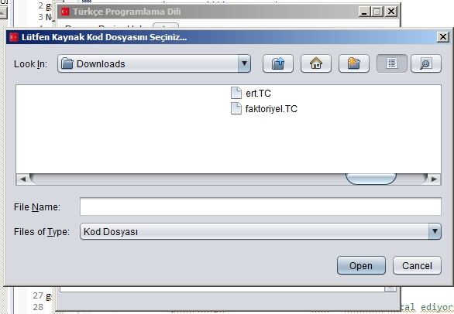

menu item is used for opening a saved file from the computer.If there is a previous code that is not saved in the code section of the window , the program will warn the whether to save the code or not.If the user wants to save the code the Save File window will be opened and the user enters the new file name and the file is saved.Then the opened file is loaded and the code is shown in the code part.

Kaydet... menu,

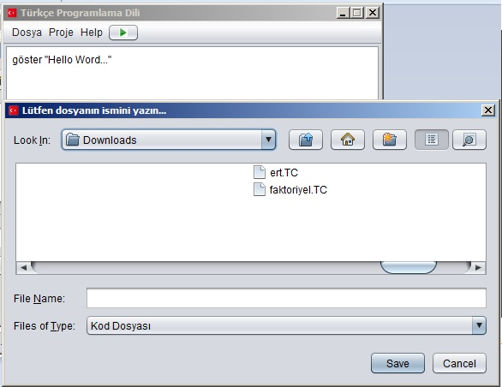

is used to save the code the a file.If the file is being save for the first time the Save File window will be displayed and the user enters the new file name and the file is saved.After first saving when the user pressed this menu the Save File window will not be displayed because the window program is keeping the filename from the last Save File window.If a new file is created with yeni then for the first time again the Save File window will be diplayed.

If a file is opened when the user presses this button the Save file window will not be displayed again because the window programs keeps the last open file name.

Farklı kaydet... is used to save the current file with a different filename or file extension.For each time the Save file window is displayed and the filename is requested from the user.

Kapat... is used to close the entire program.If there is a unsaved code the user will be warned whether to save the code or not.

When the user clicks the Proje button...

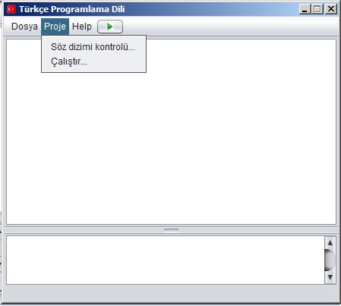

This pulldown menu is shown.It consists of two menu items that is used to perform systax checking and the running the code.

Söz dizimi kontrolü... menu item performs a syntax check operation.The source code is tested whether it fits to the language gramer.If an error is occured it will be shown in the output text area.

If the file is not saved yet the program will warn the user to save it.After saving operation the systax checking operation is performed.

Çalıştır... menu item is used to run the source code. If the current is not saved the user will be warned to save the code.After saving operation the syntax checking is performed if there is any error in the sytax checking step the error message will be shown in the output textarea and the running operation will be terminated. If there is no error in the syntax the interpreter will start to process the code. If any error occurs during the running the code the error messages will shown in the output code. If any error does not occur the output of the program will be displayed in the output textarea.

When the user clicks the Yardım section...

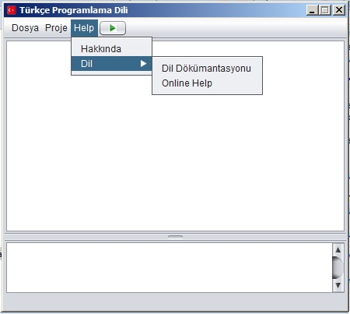

This pulldown menu is shown.

Hakkında section opens a simple popup message box containing the informaion about the program.Version number , a short description , the programmers.

When the user moves the mous cursor onto the Dil menu item a new pulldown menu is shown.It contains two menu items.

Dil Dökümantasyonu menu will open the help window of the program.

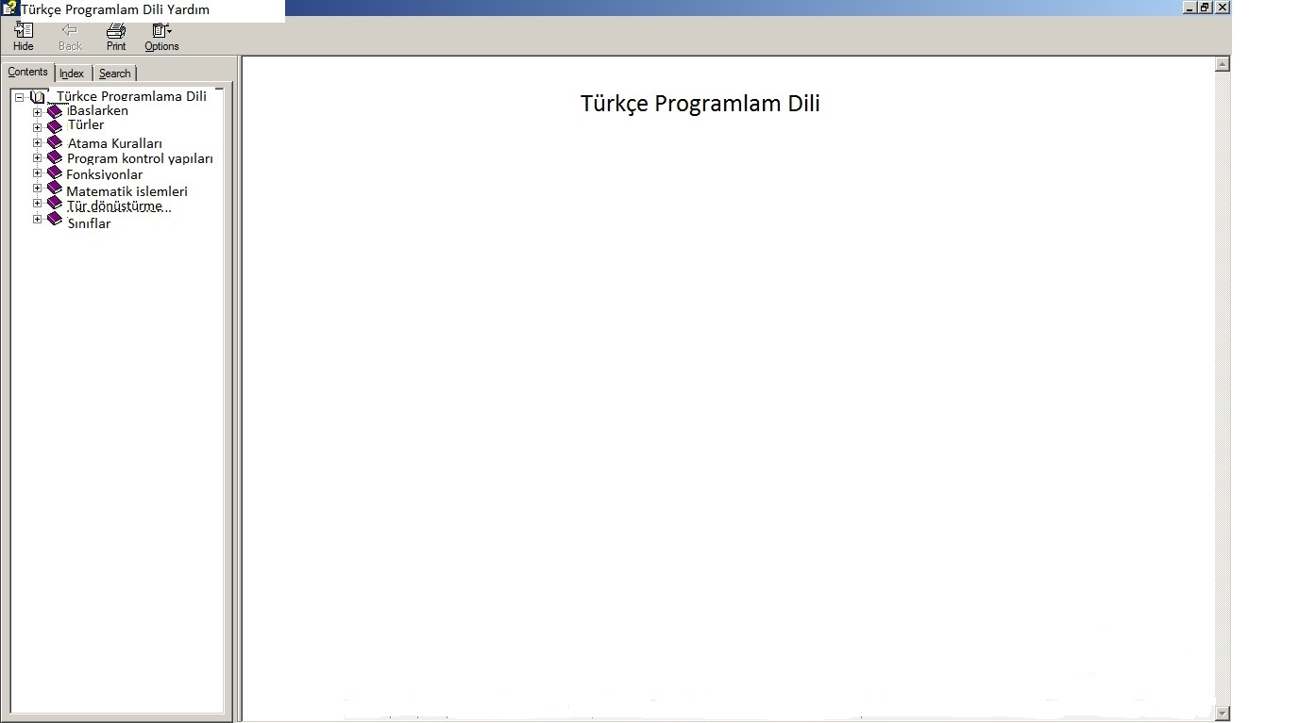

Online Help menu item will run the web browser and display the language specification of the web application.

When the user clicks the button on the menu bar , the program will perform a syntax checking then run the program code.If the file is not saved yet the user will be warned to save it.If an error occurs in syntax checking or in the running program the error messages will be shown in the output textarea.The output of the program is displayed in the output textarea.,

Output window

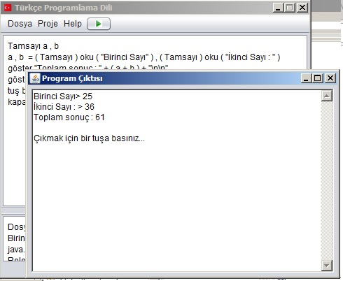

The user will see the all the output of the program from this window.Also while entering input such as name ,number ,values to the program he/she will use this window.

System Design

System Architecture

Operating System : Our desktop program can run any desktop operating system that supports Java Virtual Machine. Linux , Mac , Windows...Desktop program has not been designed for the smartphones or tablets .

For the web application any operating system that supports a web browser can use the web application of our system . ( Android , Simbian , Windows , Mac , Linux .. )

Platforms : The desktop part of projection is for PCs. Any platform that is able to run virtual java virtual machine might run our desktop program.( Desktop computers , laptops , on board computers ( Rasperry Pi , Radxa Rock...)

For the web application of our system , any platform that is able browse any web site can run our program . ( Smartphones , tables , simbian cell phones , PCs , laptops , on board computers , Tvs )

Programming Language : For the desktop program all the parts of the system ( lexer , parser , interpreter , output windows , main window ) will be writen in the Java programming language.

For the web application , the server side program that manages the file uploads , file downloads , running the interpreter by supplying the source will be written in PHP programming language. For the web site HTML language , CSS style language and the JavaScript language will be used...

Component Diagram

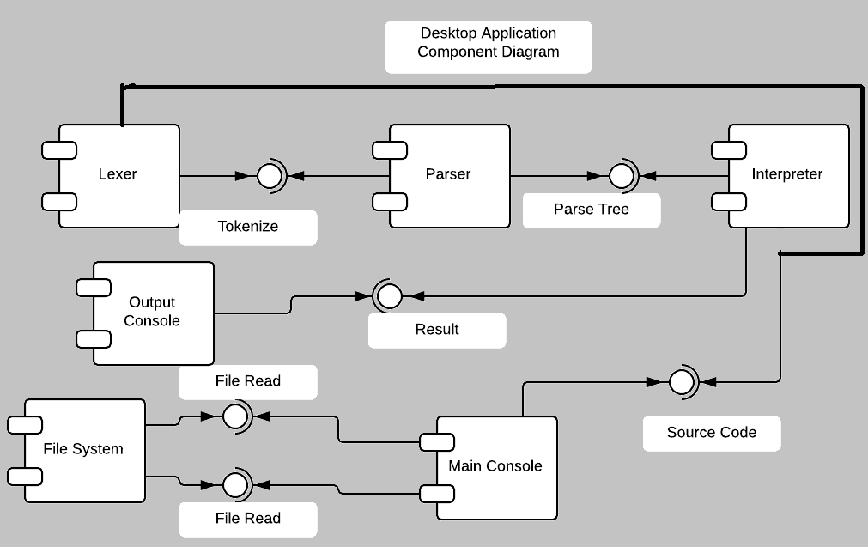

The desktop application of the system consist of 6 components.Lexer is the component that takes the source code tokenizes it for the parser. The lexer tokenizes the source code and passed these tokens to the parser compont.The parser component takes these components and constructs the parser tree that will be walked through the interpreter. The interpreter runs the code and send the output ( error , code output ) to the output console. The output console takes the result and it displays to the user.

The main console performs users GUI operations.( File reading , saving , help documentation , running start , sytax checking start ).It provides source code to the lexer component. The Main GUI uses the operating system’s file system to save and read files to the machine.

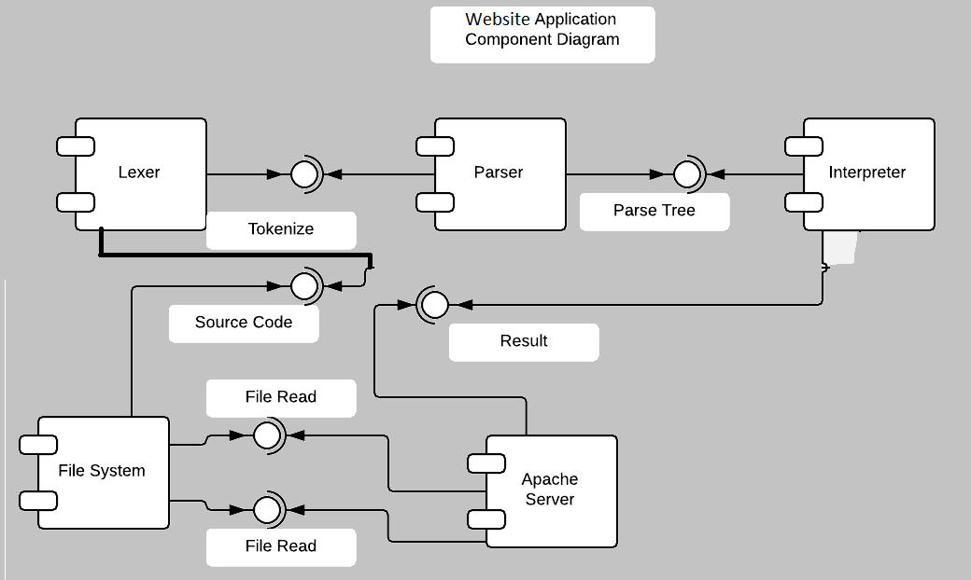

The web application consists 5 main components.The lexer reads the source code by using the file system’s of the server machine and tokenizes it for the parser. Then the parse takes these tokens and creates the parser tree. Then the interpreter takes this parse tree and executes the code. Then it sends the result ( error , code output ) to the apache server.Then the apache server sends the output the client machine. When the client request a code execution the apache server takes the user code and saves it with the interfaces provided by the server machine’s file system. Then triggers the lexer to read the saved source code.The might request to downlaod the source than the apache server reads the file from the file system of the server machine and sends it to the client.

Deployment Diagram

Desktop App Deployment Diagram

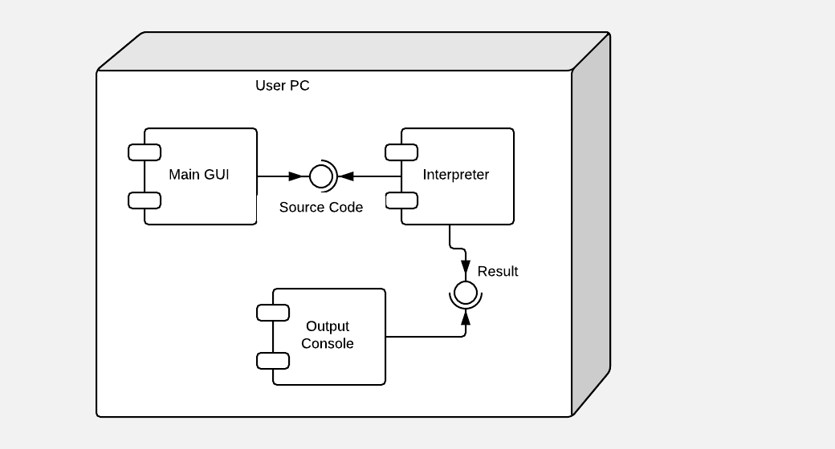

( The interpreter component of the deployment diagram actually consist of the lexer , parser , runner components.)

In the desktop application the only node is the PC that can run the java virtual machine for the PC. The whole program can be divided into three part. Main GUI is the part that performs all the file operations ( reading , writing , loading ) , displays the language documents . The interpreter is the real code runner part.The syntax checking and the interpreting the code occurs in this component.

The output console is the component that interacts with the user while the code is being run.The user enters the input to that component and sees the result of the program from that component.

Main GUI supplies the source code to the interpreter , the interpreter takes this code produces the output ( error , output of the code ) and sends it to output window.Then the output window displays the result to the user.

Web App Deployment Diagram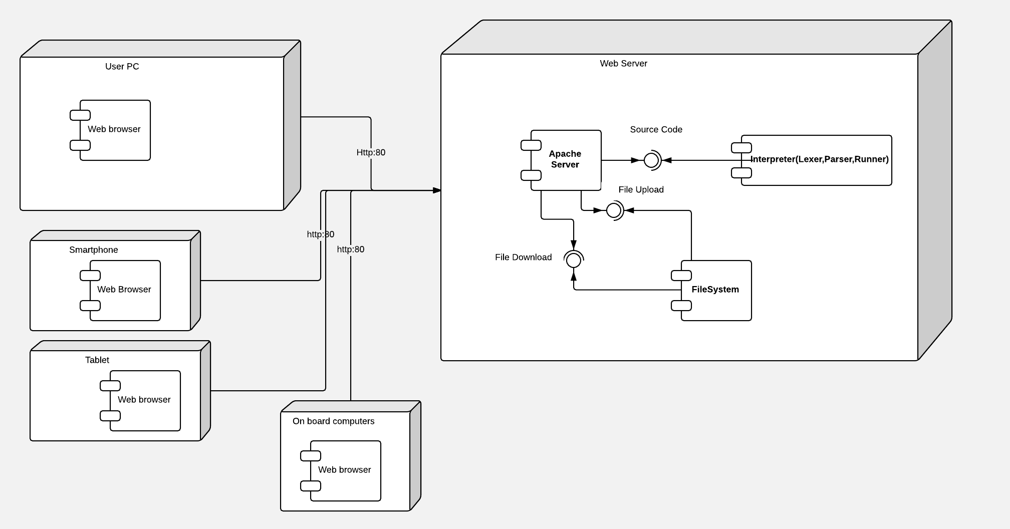

In the web application , server of the system is node. The connecting devices are the other nodes.The web application can be run from the any device that support the web browser.The devices are using the http protocol while accesing the website in the internet.

In the server side the apache web server is running.It supplies the requested pages , files to the clients.It sends the source code to the interpreter and the interpreter takes the code runs it returns the result to the apache server.Then the apache server sends the output to the client.The output may the output of the code or the error message caused by the syntax checking or running the program.

The apache server stores the saved file in the server machine.or it can read a file from the server machine with the provided interfaces by the file system of the server machine.

Program Design

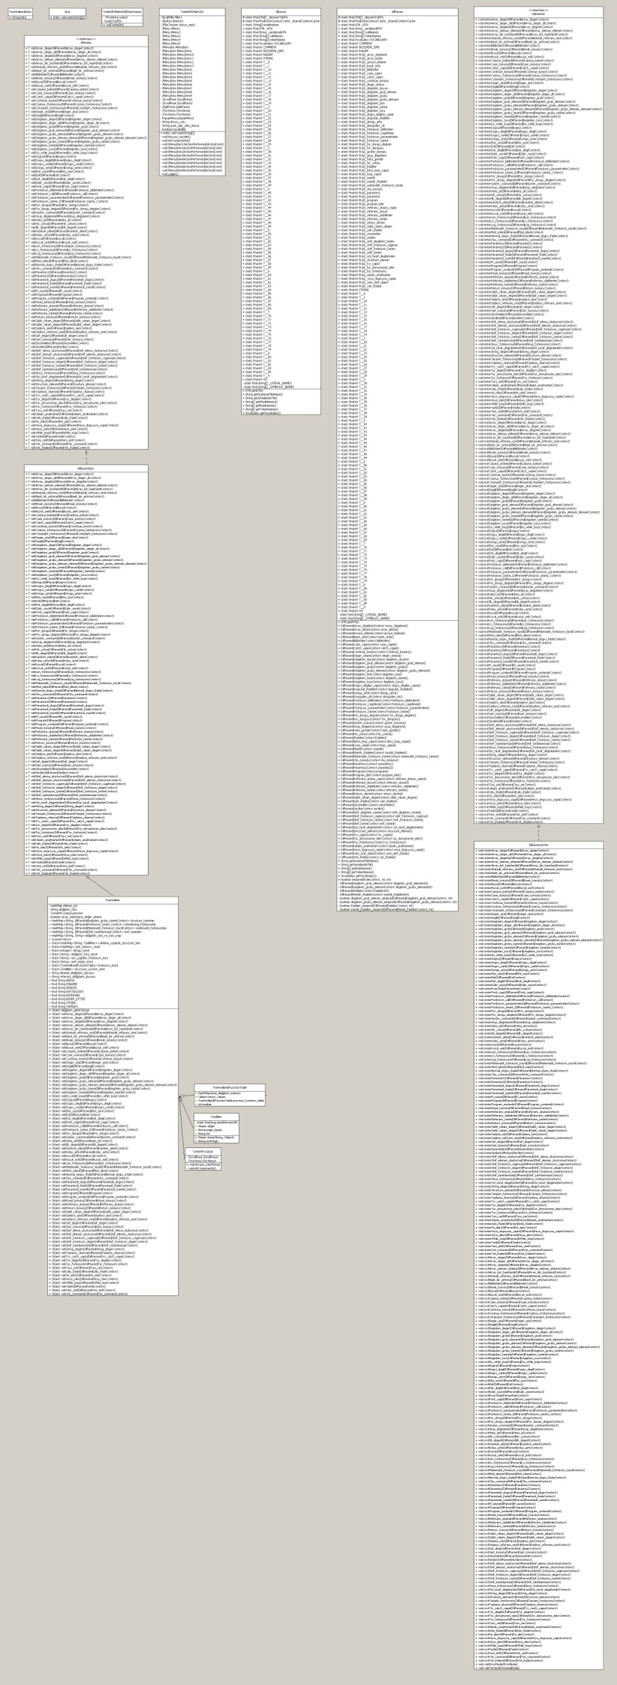Class Diagram

DilLexer , DilParser , DilListener ,DilBaseListener,DilVisitor,DilBaseVisitor.These classes are responsible for the lexing and the parse tree creation.

Treewalker is the main class that the program ( source code ) is being executed.

TurkishPLMainGUI is the main GUI application.

Özellikler is used in the TreeWalker.This class stores the information related to the variables used in the program.

TurkishPLOuput is the output application.

Function table class is used in TreeWalker.This stores the required information while executing the languages functions.

TreeWalker$Goto is used in the TreeWalker while performing exception handling in the language.

Use Case Diagrams

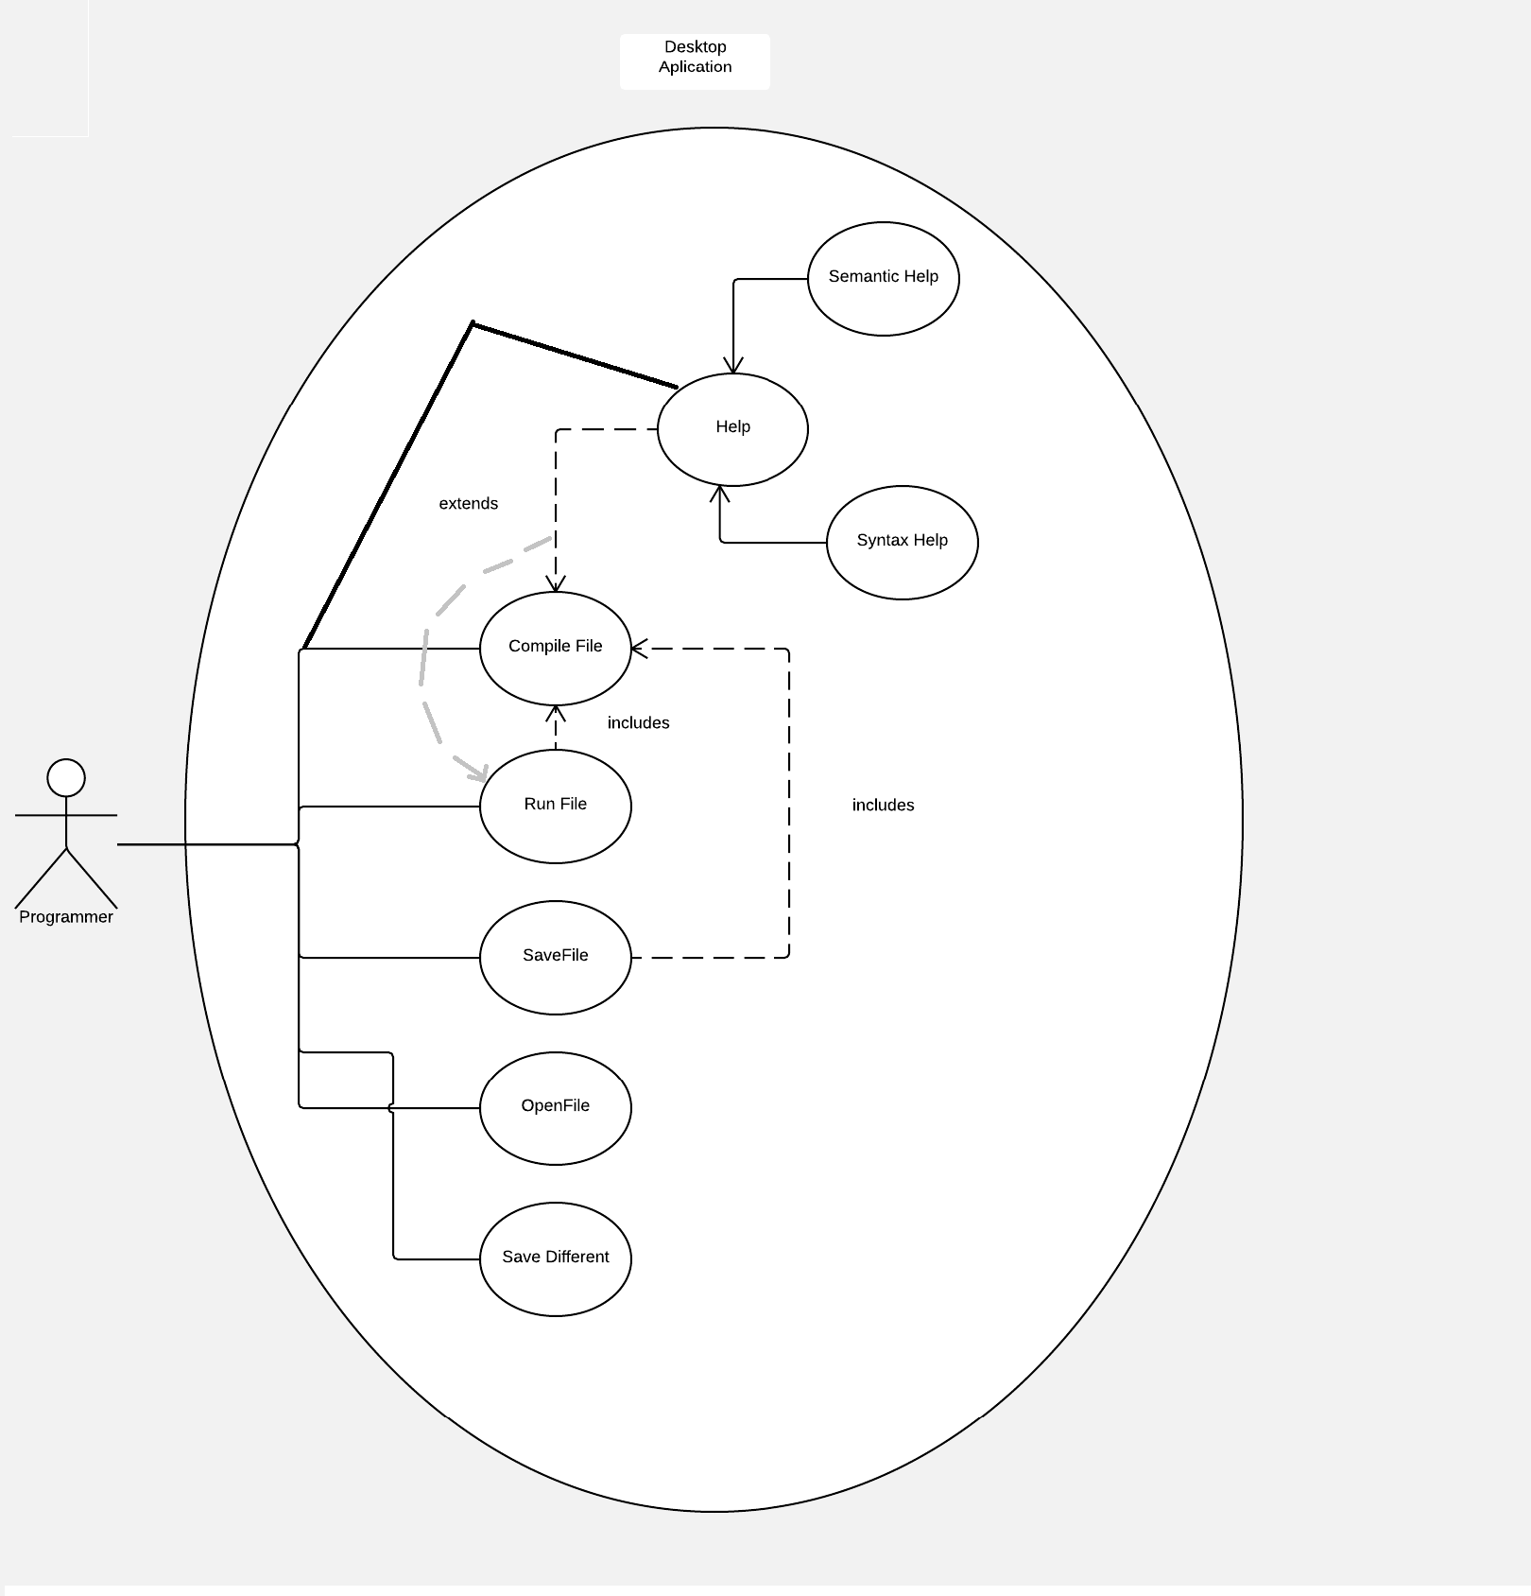

There is only one actor in the desktop application.He/she can perform file opening and saving on the PC.He can save the current file as a different file or the same file type with different file name.

The user may read the language specification and example codes in the program. He/She can perform a syntax checking if something goes wrong the help section will be displayed. He/She can run the code.Running the code requires the compile file operation without compilation the run operation can not be performed.Again if something goes wrong in the running state the help section will be activated.

The help section consists of the syntatic help operation occurs when sytax error occurs and the semantic help operation occurs when the running the code.

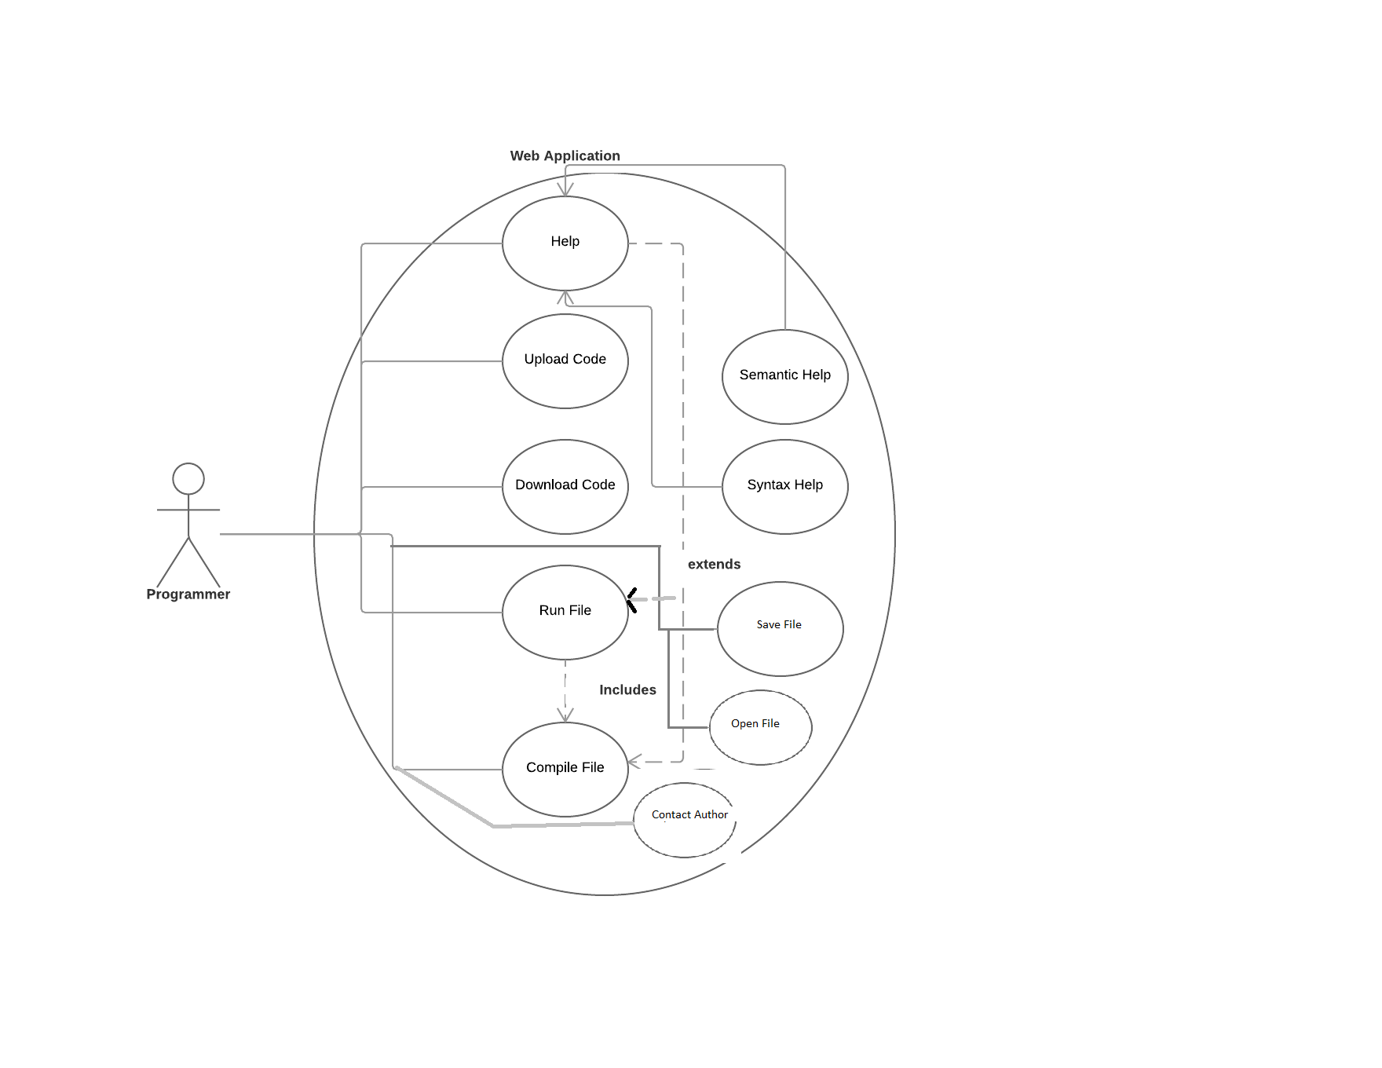

Compiling refers the tokenizing and syntax check...

In the web application there is only one user.The user may read the language specifications.Inspect the example codes. He/she can upload his code to website and continues developing from the web application.He/she can run or compile the code on the website. For running the compiling operation must have been performed.Without compiling operation the run file operation can not be performed.

While running operation or compiling operation is being performed an error may occur.The help section of the error will be shown to the user.

The user may download the source code from the website and continue developing on the desktop application.

On the website the user may save or open his/her code on the server.

The help section of the program consists of two types of helps.One is the syntax help the other one is the semantic help. The compiling operation will cause the syntax help , the running operation will cause the semantic help.

In the web application the user may contact with the authors of the language about the bugs or for more information.

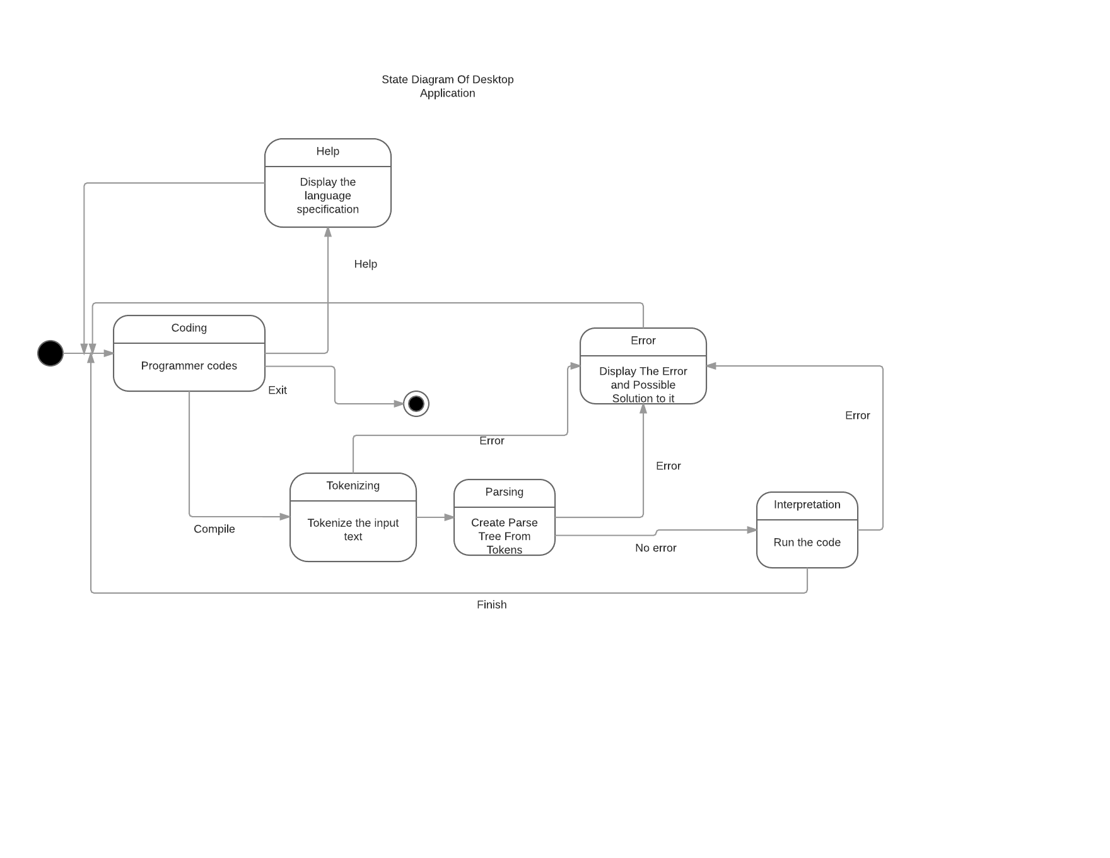

StateChart Diagrams

The desktop program can be divided into 6 states.The user passes through those states during the development.

When the user opens the program first it is default in the coding state.

Coding state is the state in which code writings and loadings are performed.

Help state is the state in which the programmer gets help from the user.The help section of the language is shown to the user.

Tokenizing state is the state in which the written or loaded source code is divided into tokens that will be used by the parser.If something goes wrong the program passes to the error state in which the error messages are shown.From the error state again the program returns to coding state to fix the bugs.

If tokenizing has gone well , the program passes to parsing state in which the program creates the parse tree that will be later walked through in running state. If something goes wrong the program enters the error state in which it displays error messages to the user.

If the parsing state has gone well the program enters the running state in which the source code is executed.Again if error occurs the program goes into the error state and displays the errors.If no error it show the output program then passes to the coding state for new runs.

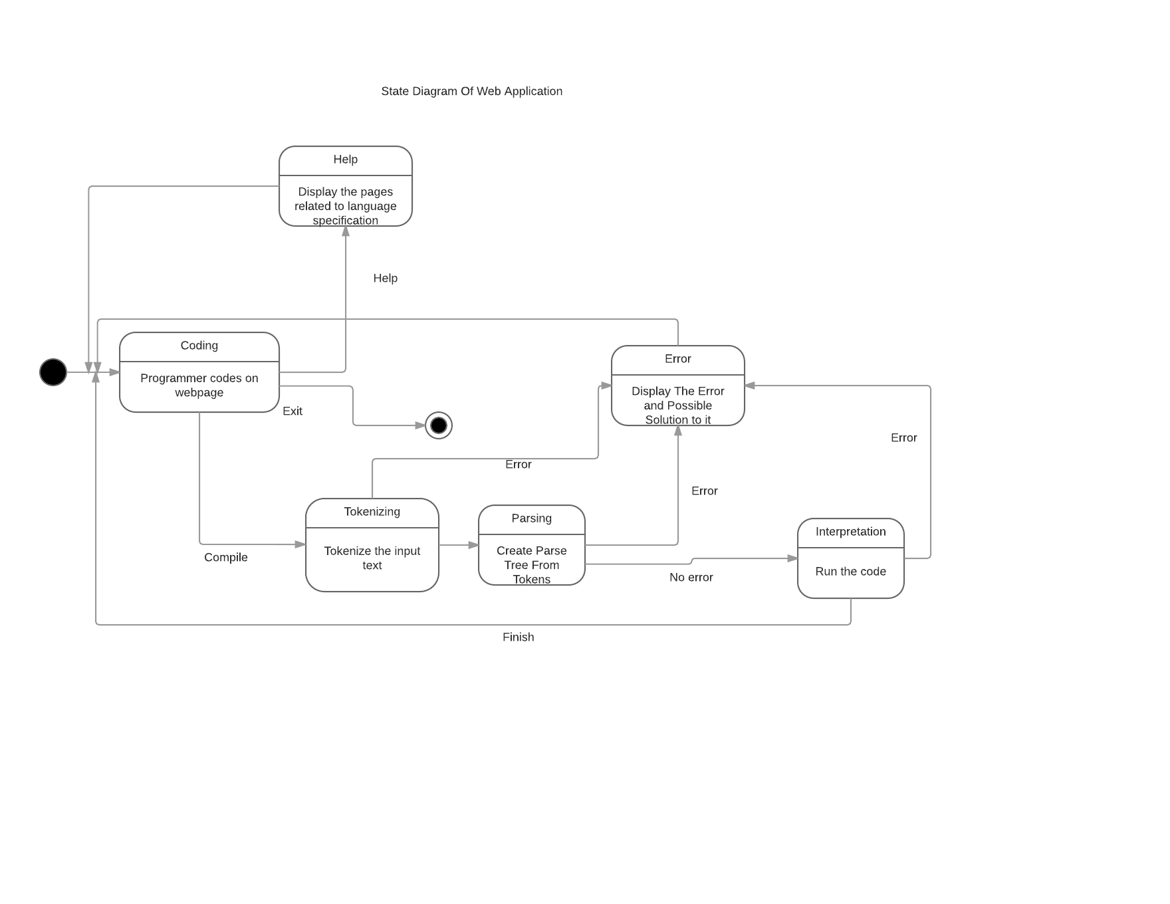

We can divide the web application in 6 states.The user travels through this states during the development.

Coding state is the starting state.When the user open the web application this state is present.All the file openings code writing actions are performed in this state.If the user wants to get help then the user opens the language specification and the web application displays the help contents.Examples are also help content the user might get an idea from the example codes.If the user wants to run the code.First the program must enter the Tokenizing state.In this state the program tokenizes the source code if an error occurs the operation is terminated and the error message is shown then the program is in error state.If there is no error the program passes to next state parsing.In this state the interpreter creates parse tree of the source.Again if something goes wrong the program enters the error state and display the error messages.If everything goes well the interpreter enters the run state and executes source code and displays the result to the user and returns the coding state again.

After error state ( error is shown ) the program returns the coding state for the problem to get fixed.

If the user closes the web application the program terminates.

Data Design

ER Diagram

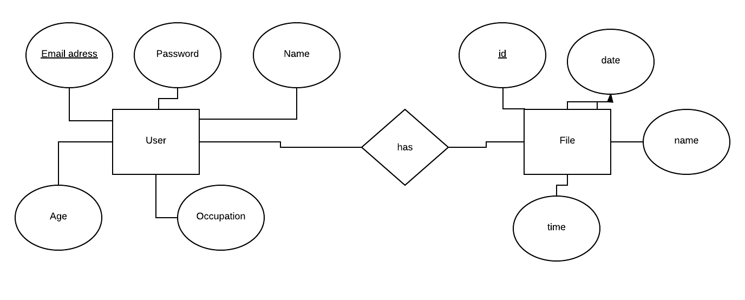

The website database will hold three tables.One is the user table this table will contain the information releated to the user.Email address of him/her . It will be used in the login page whether the user exists or not.Every person has a unique email address therefore it the primary key of the user table.the password field will store the user’s password again it will be used in the login process for the security.

Name field will store the name and surname of the user.

Age field will store the age of the user.This information is useful when giving feedback.

Occupation will hold the user’s job information.Again this information will be used when giving feedback to user.

Has table has two colums the primary key of the user table and the primary key of the file table ( id ) . If represents the user file relationship.One user may have more than one number , but one file can not be possed by two different users.It primary key is the combination of the primary key of the user table and the file table id.

File table will store the information of the user’s code file.Every file has a unique id and it is the primary key of the table.Created date and time are stored in the time and date fields.

Name field will store the filename.This information will be used while opening the file. The actual code will be stored in the server.From database the file name will be obtained and by the file name the file stored in the server will be opened for reading.While saving the code will be saved on the server and the name will be stored in the database.